
Open Door Detector (ODD) V3
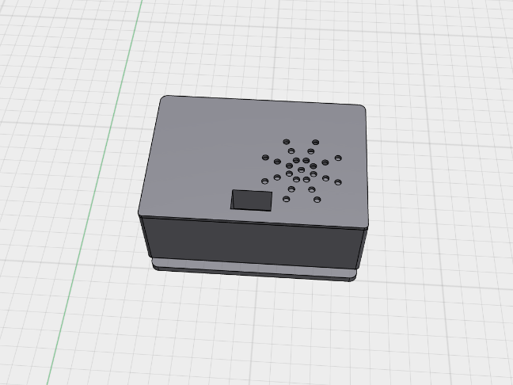
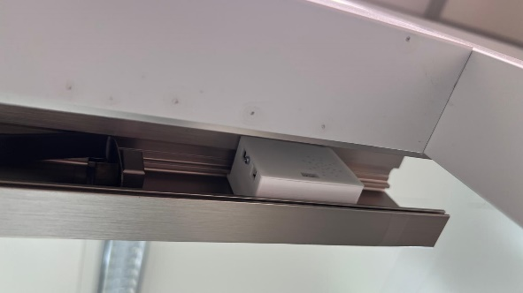

ODD is the newest version of the open door detector.
What is it for? Doors in certain zones need to be kept closed at all times to prevent germs from entering areas where food or beverages are consumed. Elab was tasked by the IMB directors to construct a device that produces an acoustic reminder if a door is kept open for too long. The intention is to alert anyone nearby to close the door.
Please be kind to ODD! We would greatly appreciate it if he is recognized as a handy tool rather than an annoying gimmick. If you have any issues regarding the device, please don’t hesitate to contact us via elab@imb.de or at extension 21563 (no work order necessary).
Please do not remove the ODD, tape it, or block its sensor, as this will activate the sabotage mode, which can only be disabled by Elab. Each ODD has its own unique number linked to the group. Loss may be considered theft.

Error Codes:
- 1x LED + 1x melody -> Sabotage (only be disabled by Elab)
- 1x LED + 3x melody -> Open door
- 1x LED + 10x melody -> Door open for too long
- 2x LED + 1x melody -> Battery is empty
- 3x LED + 0x melody -> Error

